April 25th, 2019

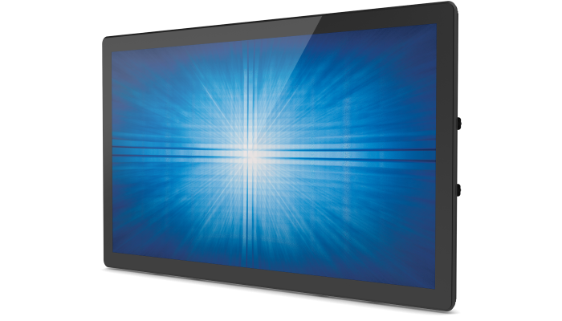Product Manager: Bryan Zirkle

Product Management Bulletin

Number: 000-701

Transition Notice: 2494L & 2794L PCAP Open Frame Touch Displays

**Product Information**

Please be advised that our current 90-Series 2494L and 2794L TouchPro® PCAP Open Frame part numbers are being discontinued and replaced with new part numbers. While we work to minimize product changes, product refreshes are needed from time to time. Please see the table below for affected part numbers.

The new 2494L and 2794L PCAP models deliver enhanced touchscreen optics and Elo’s industry leading touch thru functionality now available in the OSD. Both maintain backwards compatibility with the previous generation models, offering the same form and fit to ensure minimal design impact to your kiosk or integration customers. Additionally, all applicable 90-Series Rev B accessories are compatible with the new part numbers.

**Last Time Buy & Last Time Ship**

* Please note that remaining 2494L (E331987) and 2794L (E331401) PCAP inventory will be available on a first come first serve basis.
* Last time buy orders will be accepted through **October 25th, 2019** with last time ship to be completed by **February 28th, 2020**.
* Orders for the new 2494L (E146641) and 2794L (E707022) PCAP models will be accepted immediately. Initial samples will be available in late April 2019 with production units available in late May 2019.
* We will work closely with existing customers to navigate this transition.

**Obsolete & Replacement Part Numbers**

|  |  |  |  |
| --- | --- | --- | --- |
| **Obsolete Part Number** | **Obsolete Product Description** | **Replacement Part Number** | **Replacement Product Description** |
| E331987 | ET2494L-2UWB-0-MT-ZB-NPB-G | E146641 | ET2494L-2UWC-0-MT-ZB-NPB-G |
| E331401 | ET2794L-2UWB-0-MT-ZB-NPB-G | E707022 | ET2794L-2UWC-0-MT-ZB-NPB-G |

Contacts

For more information on price and lead time for ordering products, please contact Elo customer sales and support for assistance.

|  |  |  |  |
| --- | --- | --- | --- |
| **North America**  Toll 800-ELO-TOUCH  Tel +1 408 597 8000  EloSales.NA[@elotouch.com](mailto:@elotouch.com)  [www.elotouch.com](http://www.elotouch.com) | **Europe**  Tel +32 (0)16 70 45 00  Fax +32 (0)16 70 45 49  [elosales@elotouch.com](mailto:elosales@elotouch.com)  [www.elotouch.eu](http://www.elotouch.eu) | **Asia-Pacific**  Tel +86 (21) 3329 1385  Fax +86 (21) 3329 1400  [EloAsia@elotouch.com](mailto:EloAsia@elotouch.com)  [www.elotouch.com.cn](http://www.elotouch.com.cn) | **Latin America**  Tel +52 55 2281-6958  [EloSales.LATAM@elotouch.com](mailto:EloSales.LATAM@elotouch.com)  [www.elotouch.com](http://www.elotouch.com) |